Module 1:
Assignment 1: New Project Setup
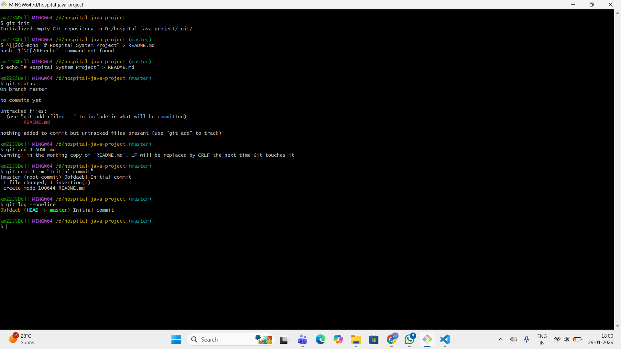
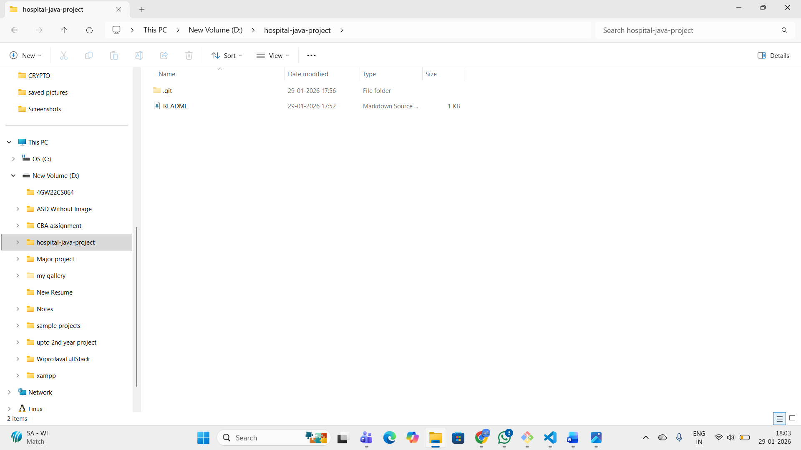

Assignment 2: Existing Project to Git
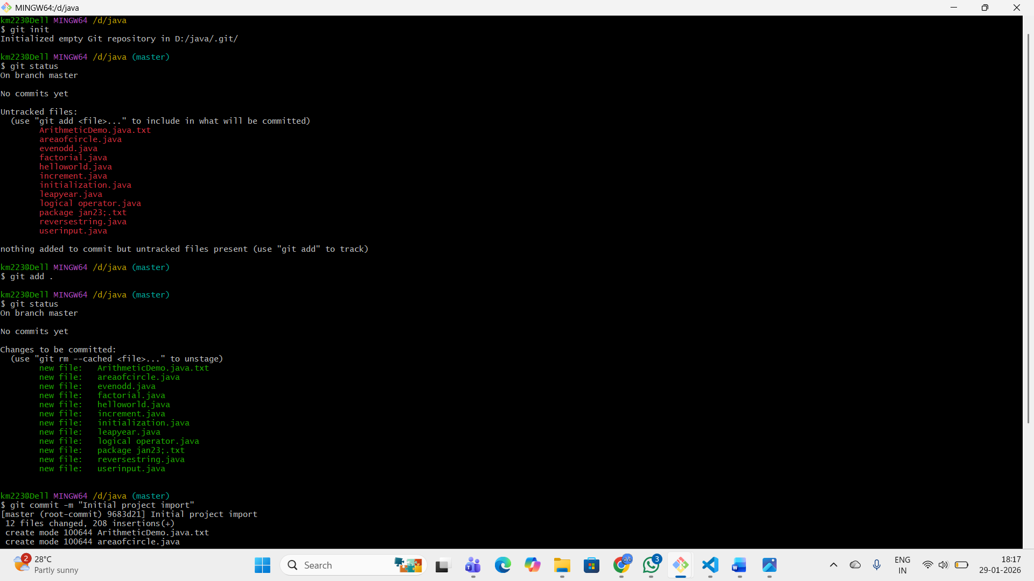
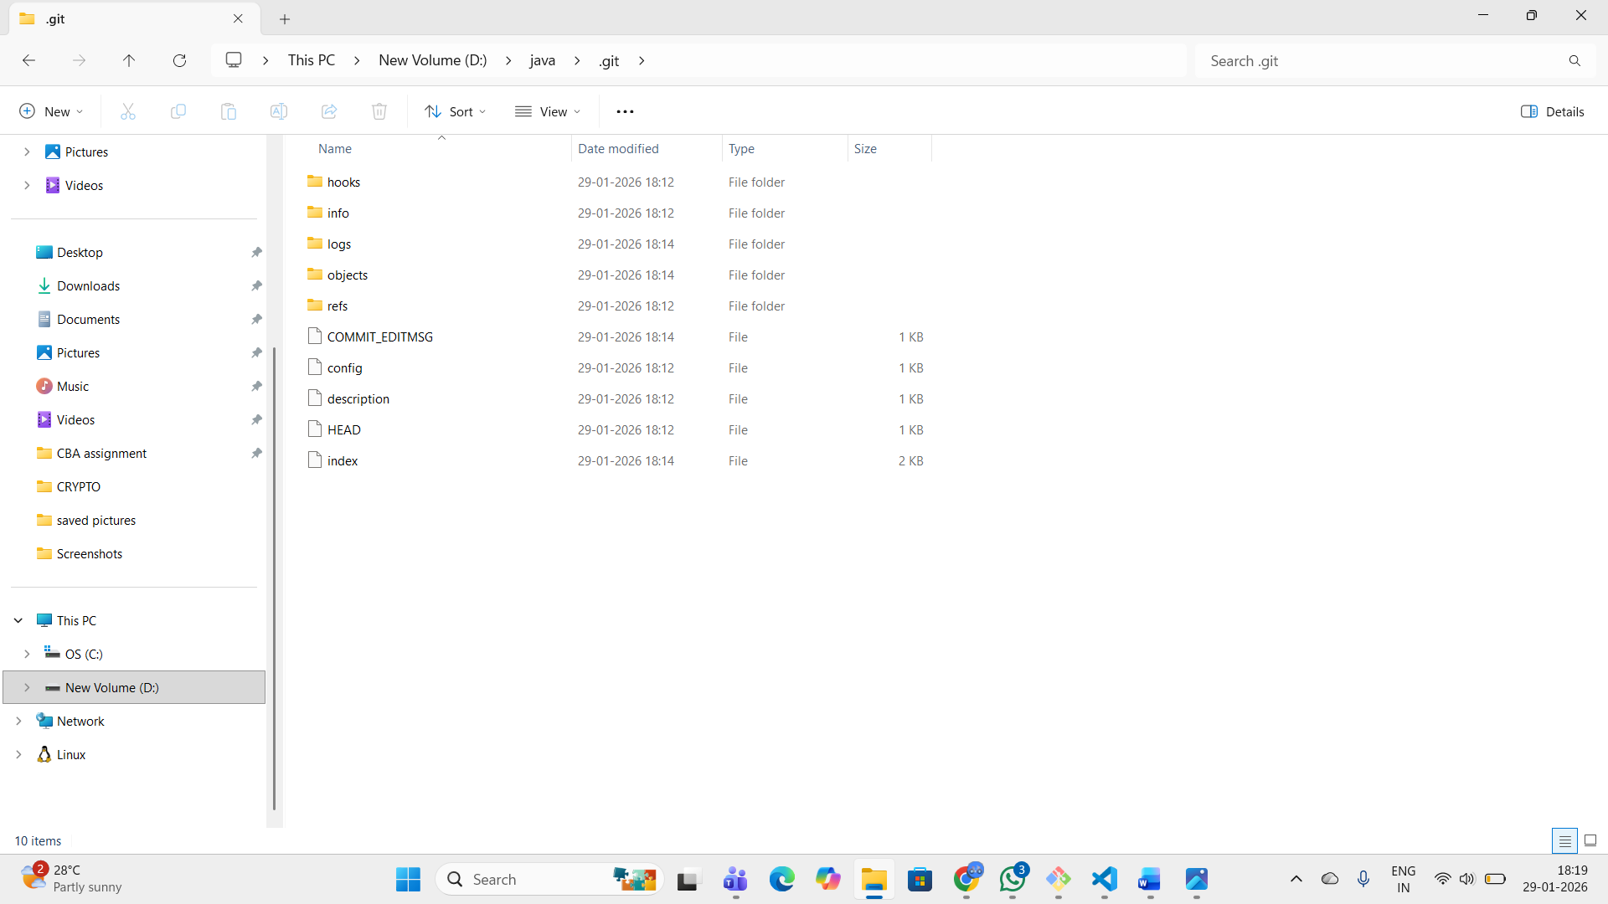

Assignment 3: Ignoring Unwanted Files
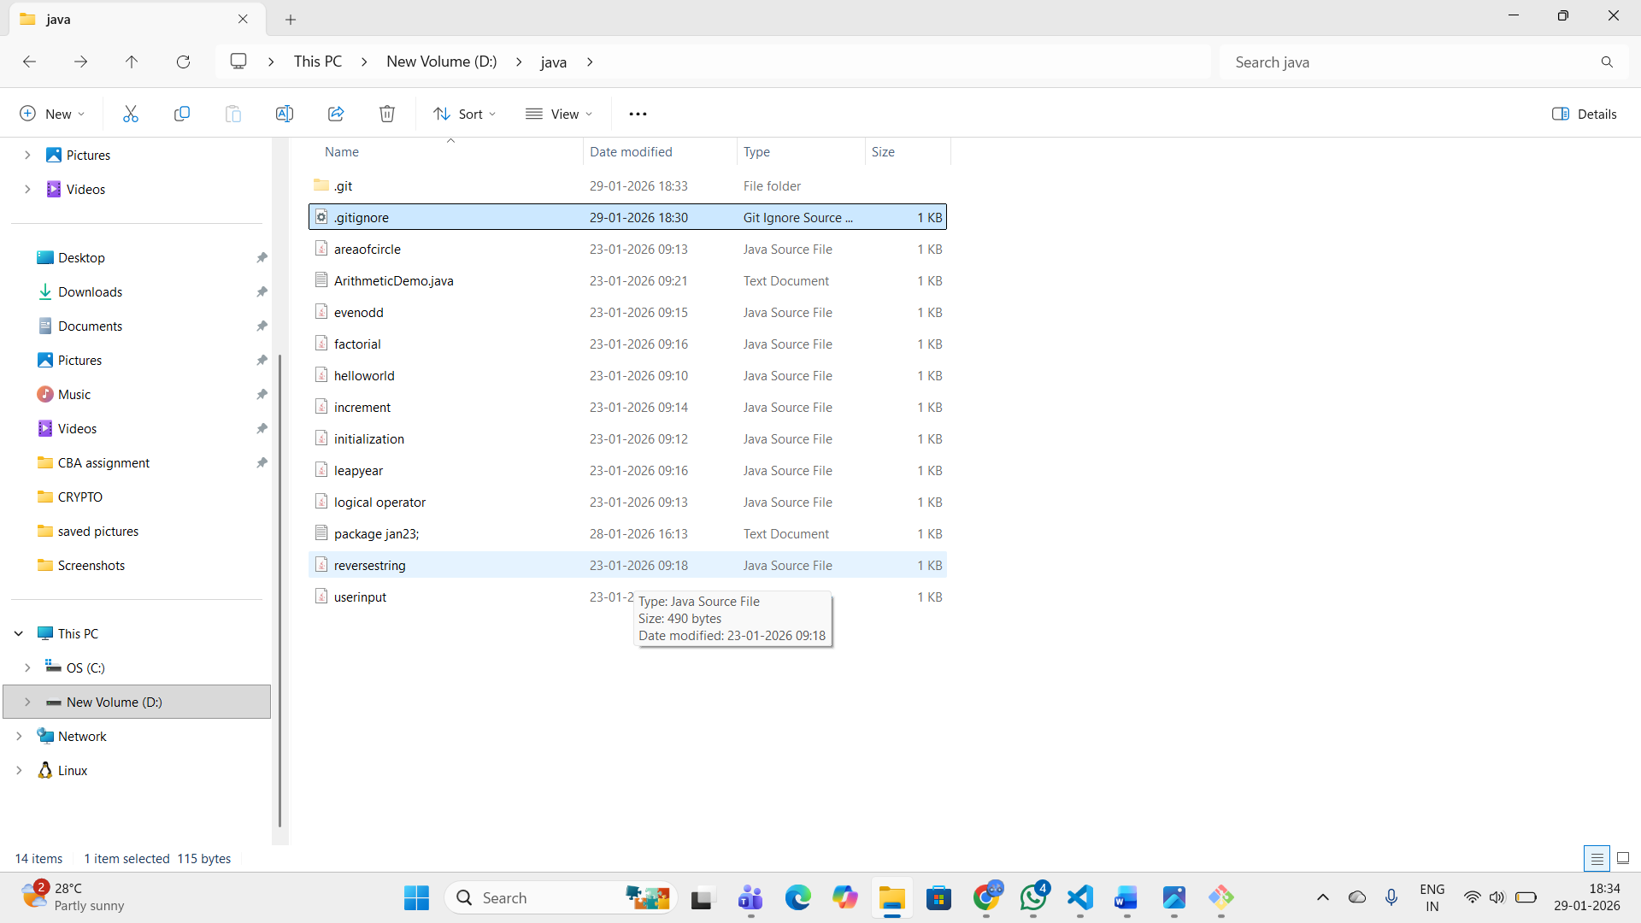

Assignment 4: Check Repository Status
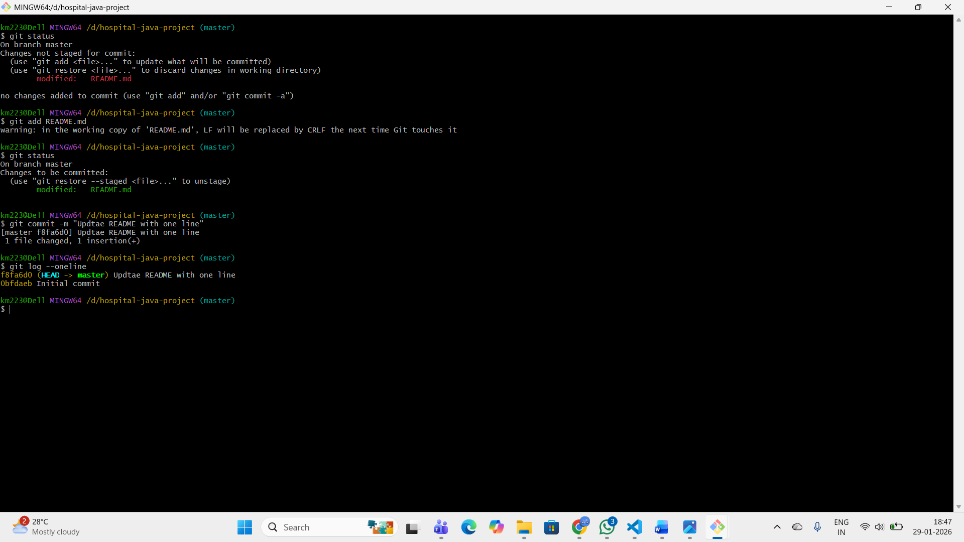

Module 2:
Assignment 5: Selective Commit
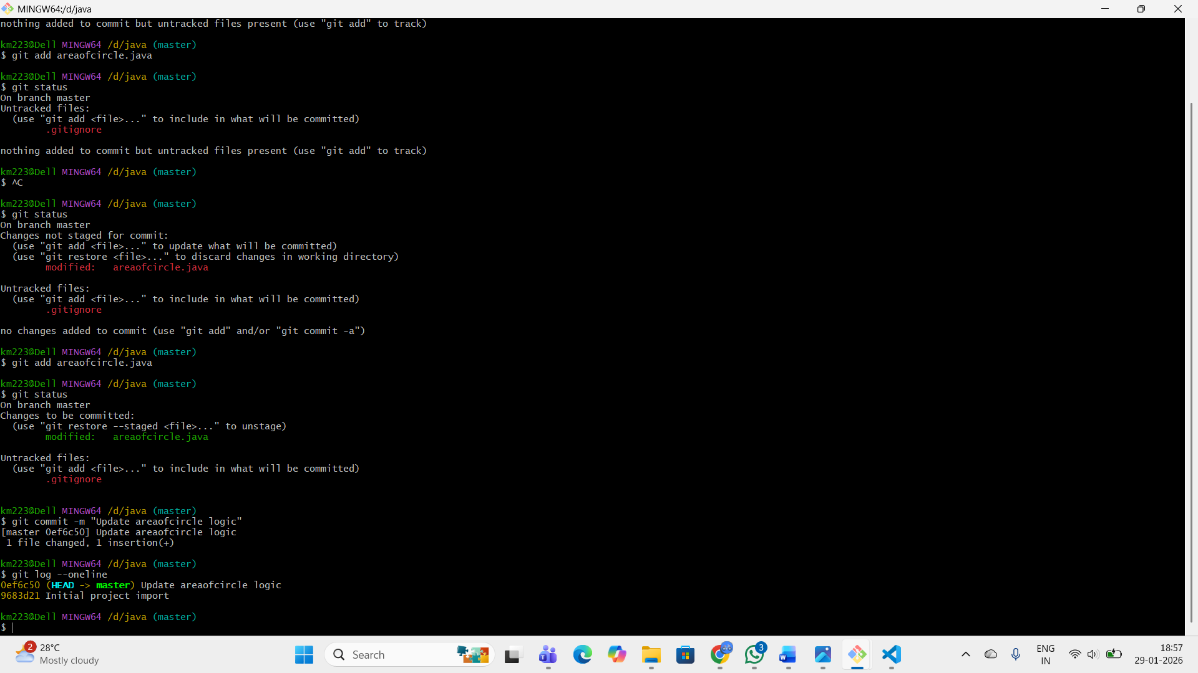
Assignment 6: Commit Message Standards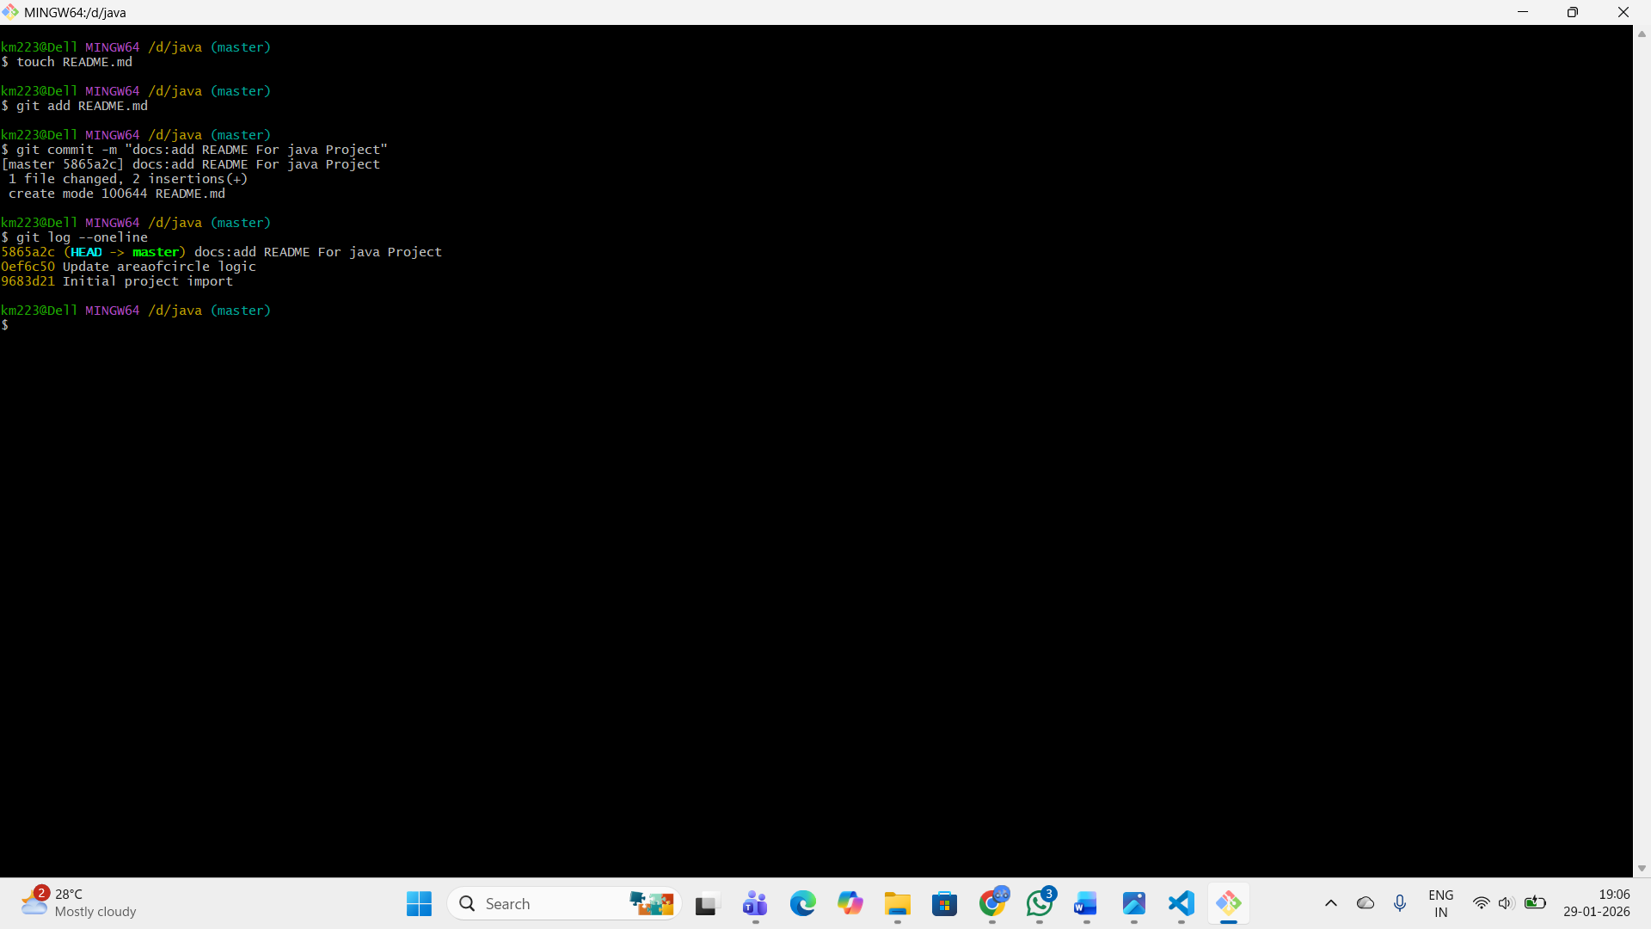
Assignment 7: Amend Last Commit
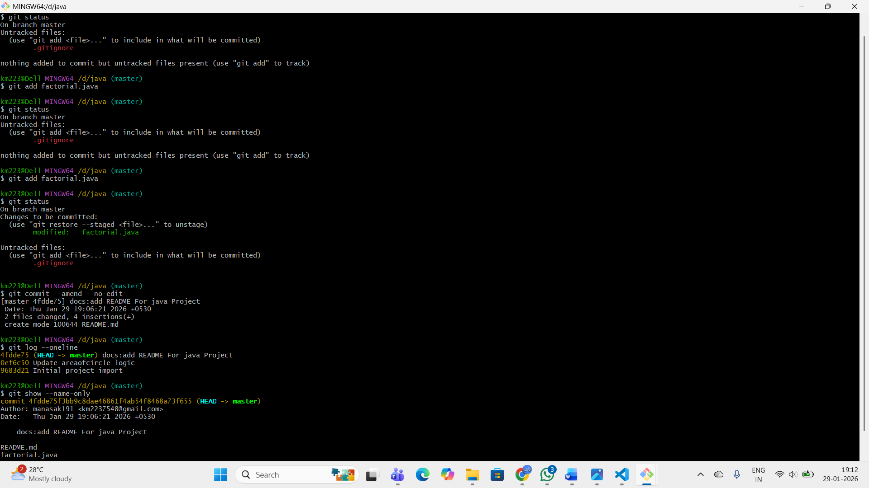
Assignment 8: View Commit History
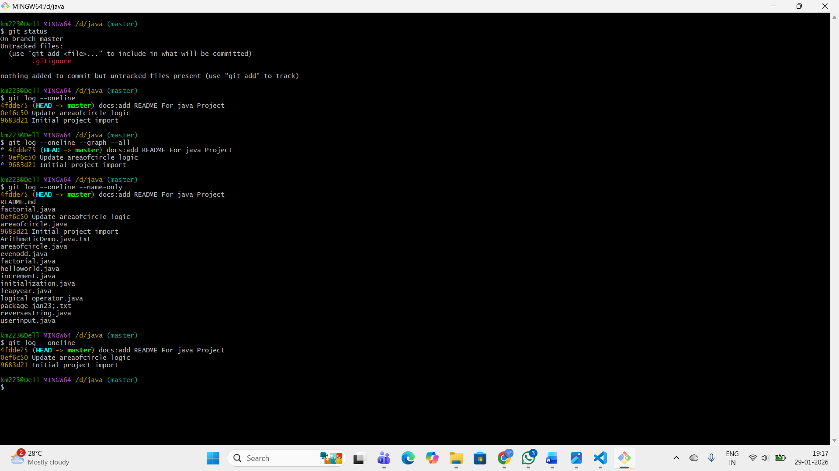
Assignment 9: Feature Development
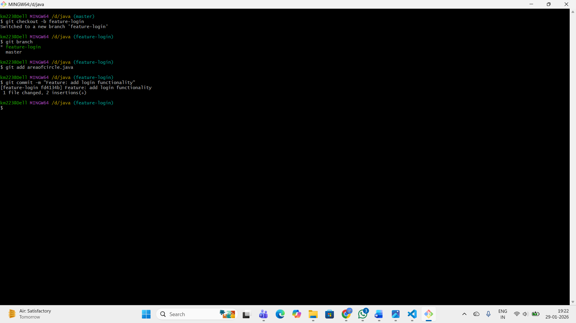
Assignment 10: Switch Between Branches
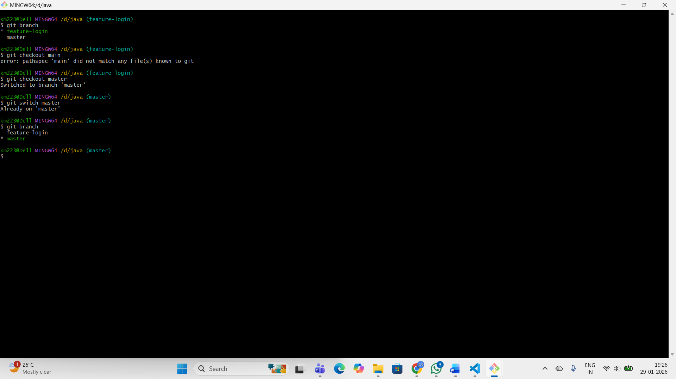
Assignment 11: Merge Feature Branch
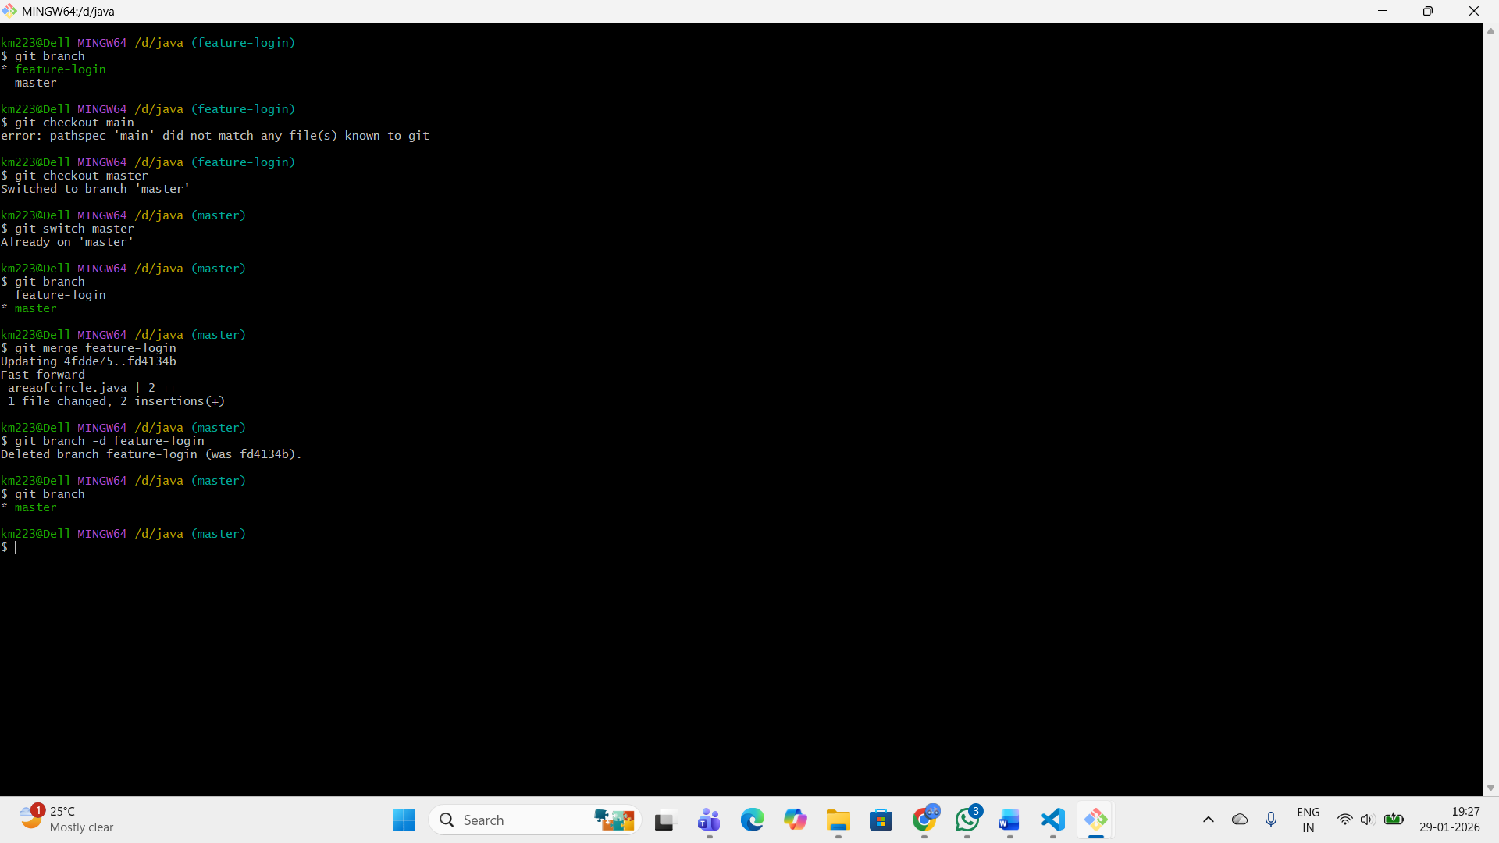
Assignment 12: Merge Conflict Handling
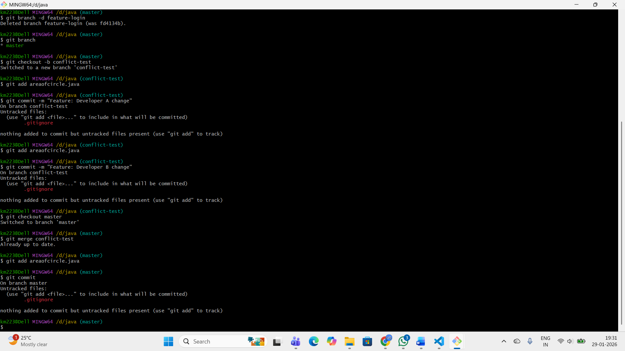

Assignment 13: Undo File Changes
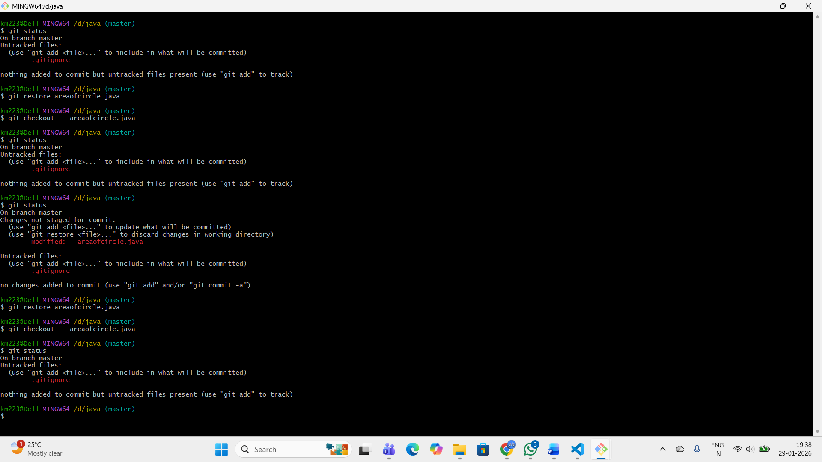
Assignment 14: Unstage a File
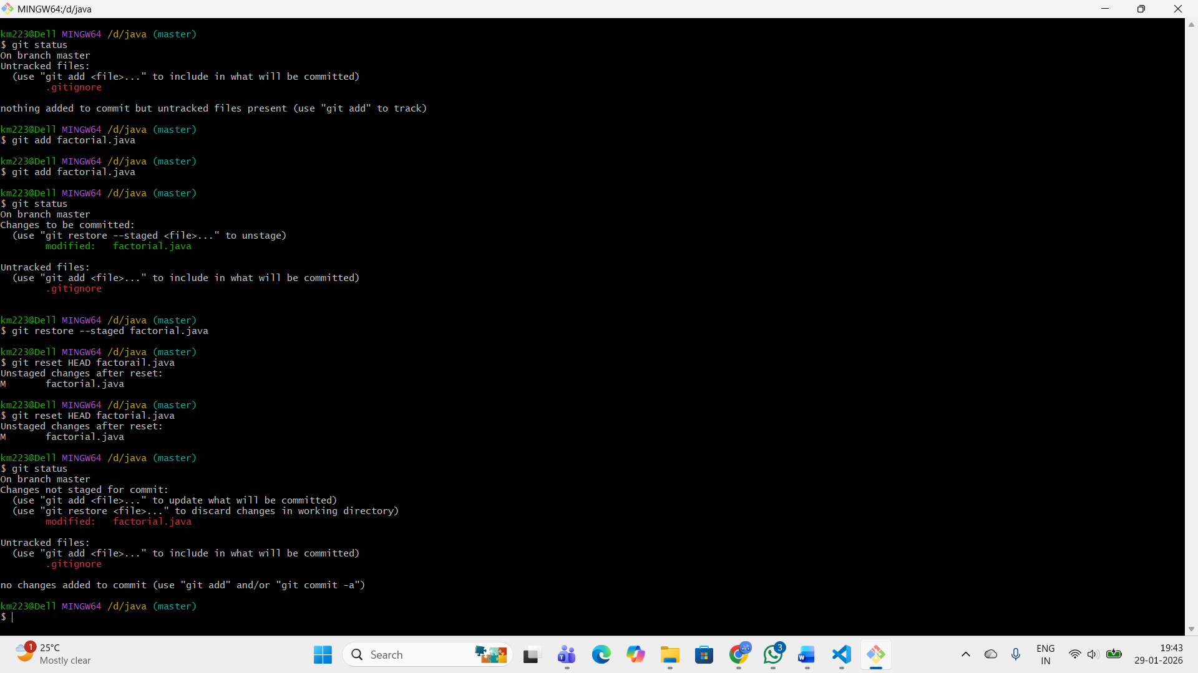
Assignment 15: Reset to Previous Commit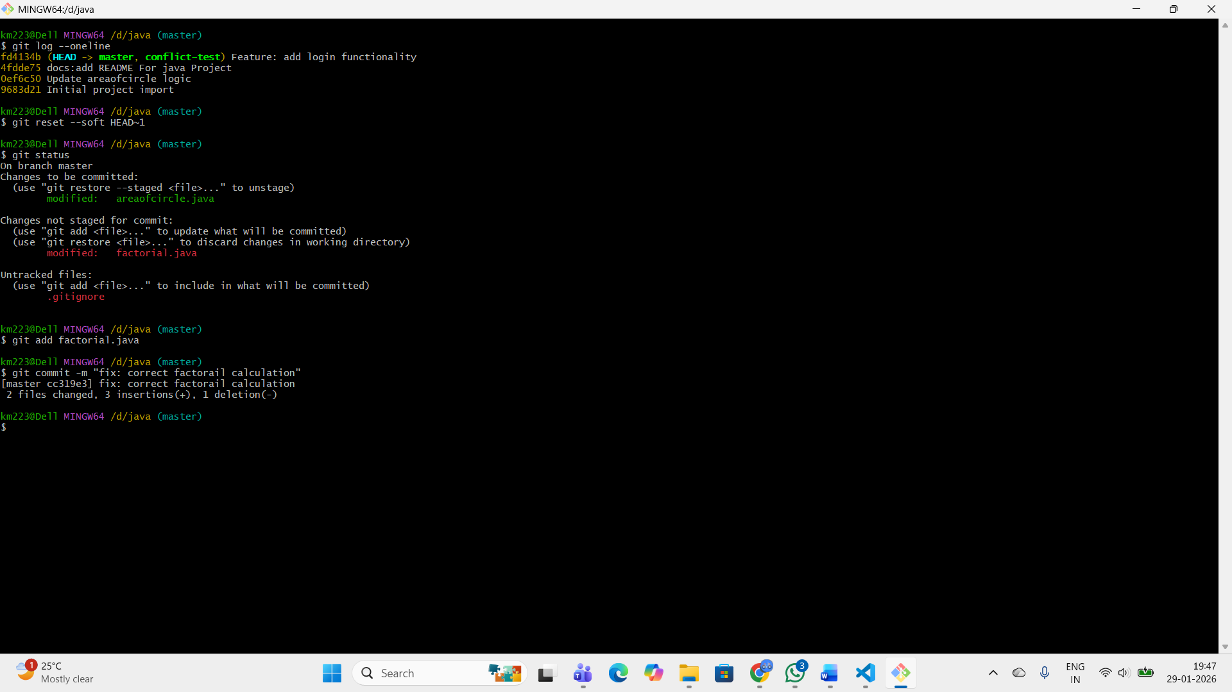

Assignment 16: Delete a Commit Completely
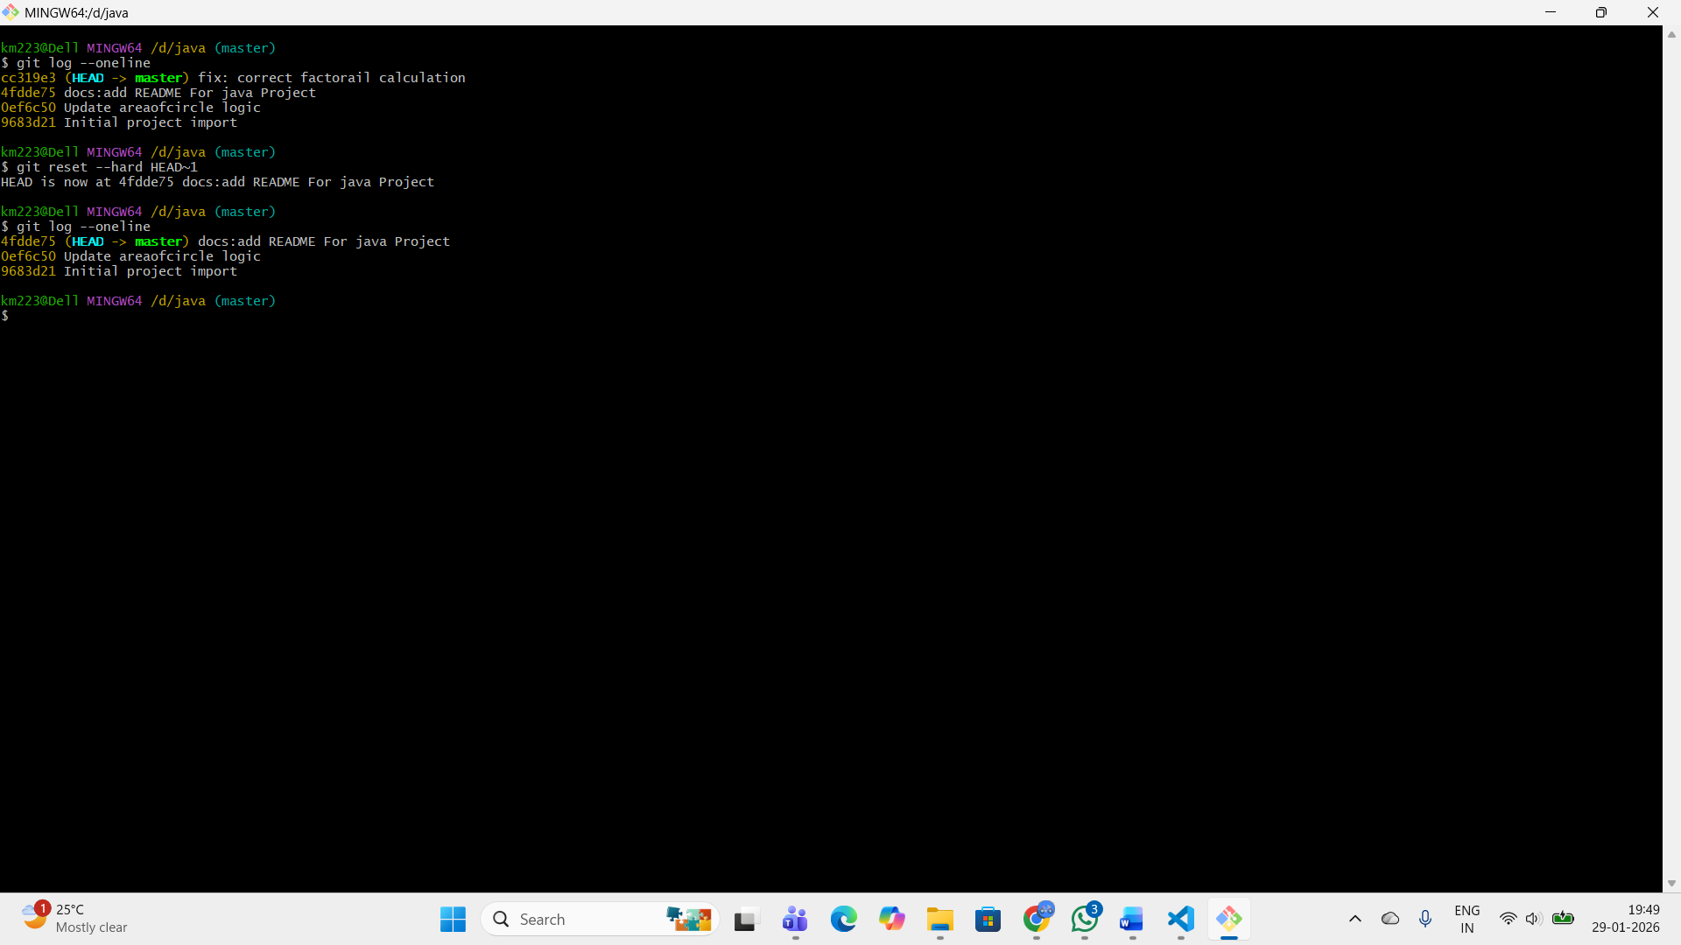
Assignment 17: Connect Local Repo to Remote
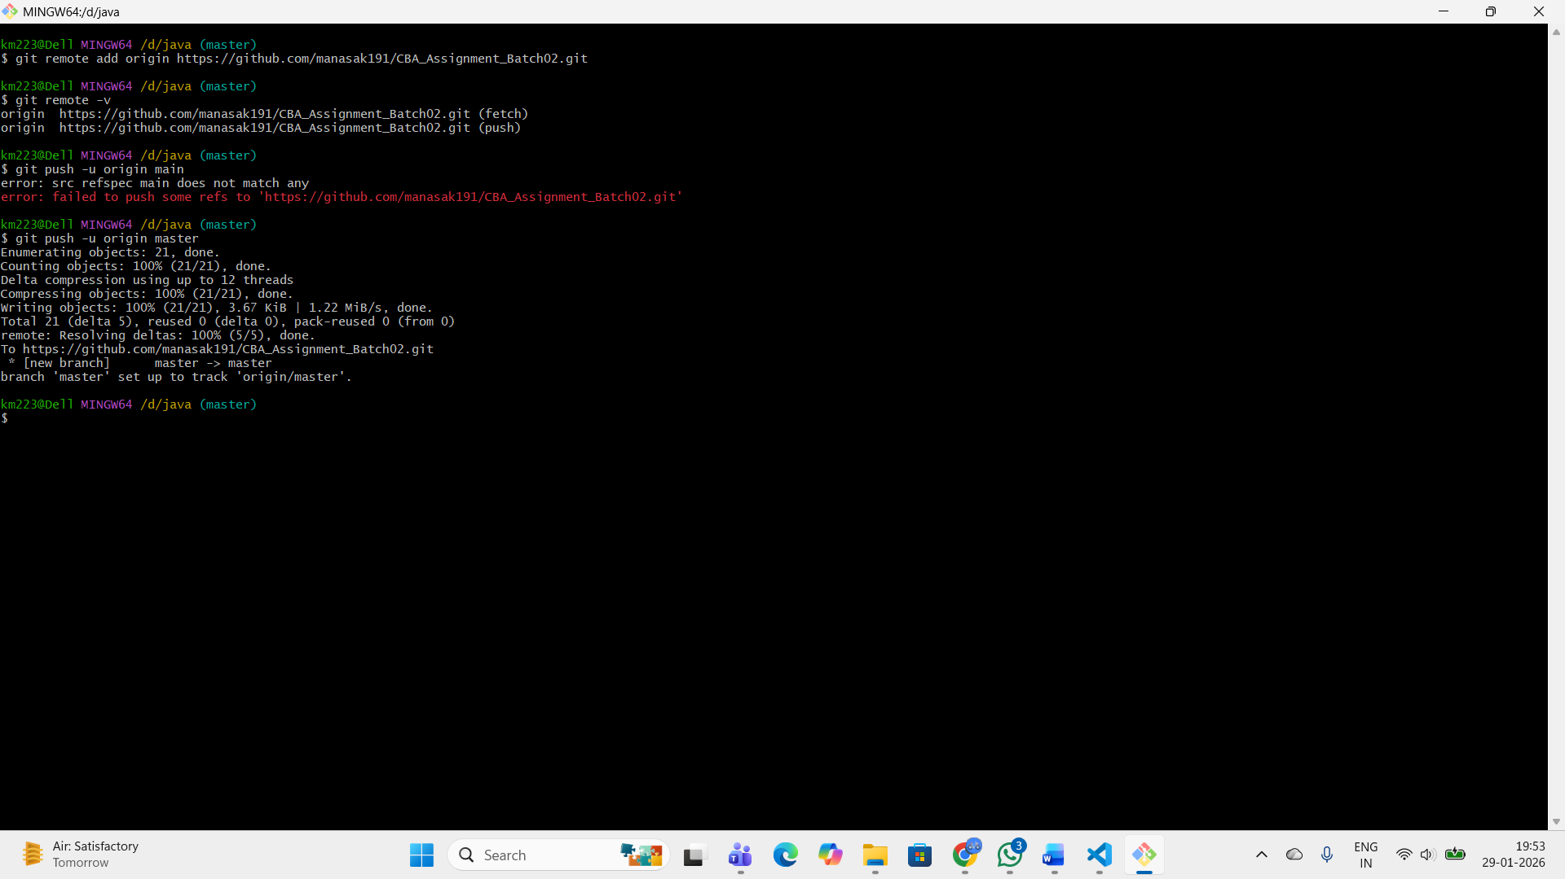

Assignment 18: Clone a Repository
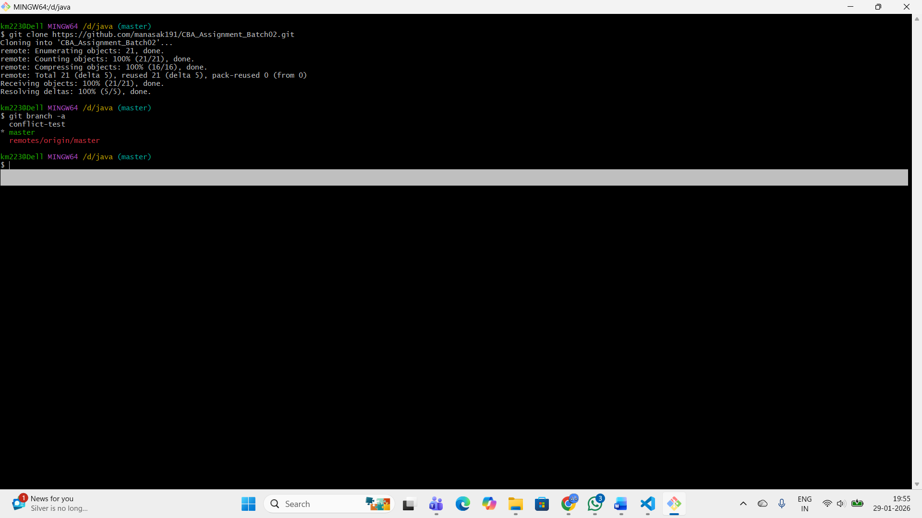

Assignment 19: Push Changes
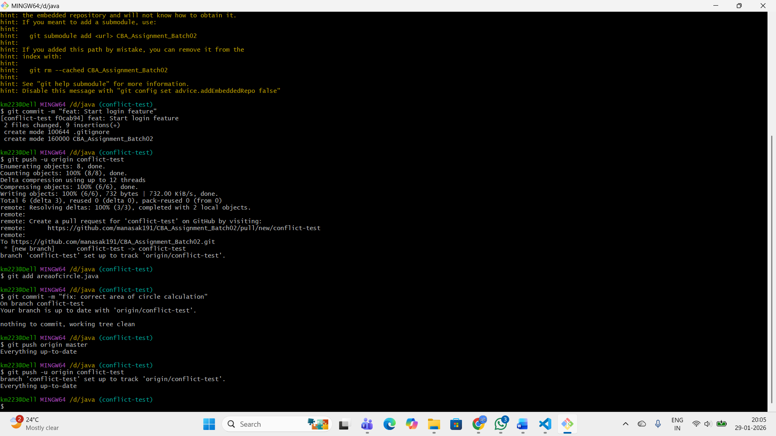
Assignment 20: Pull Latest Changes
